Pedro Inácio 59184

Code Smells

# No Comments

It can be hard for someone else, or even the original developer returning to the code after some time away, to understand what the code is doing or should be doing.

So when you see classes like TaskTable with 1000 lines and almost no comments you know something is going to be hard to understand.

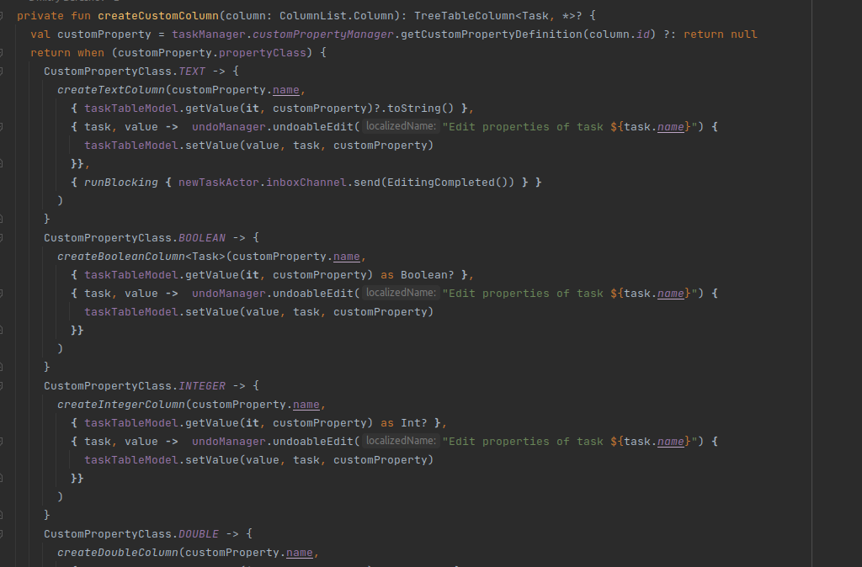

# Long Method

It’s not advisable to create very long methods, its better to just split them into auxiliar functions to allow the code to be easier to read. Not like the method setValue from lines 84 to 167 of TaskTableModel. That could easily be spitted into methods with names referring to functionality.

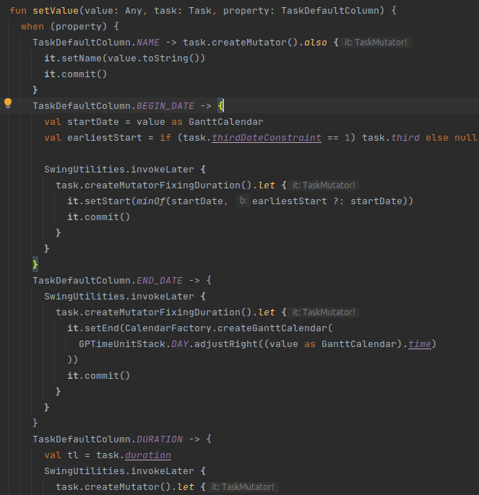

# Switch statemets

Occurs when switch statements are scattered throughout a program. If a switch is changed, then the others must be found and updated as well.

For example, if conditionals are checking on type codes, or the types of something, then there is a better way of handling the switch statements. It may be possible to reduce conditionals down to a design that uses polymorphism.

So when you go to TaskManagerImpl and see the creadteLength method with 3 switch to the same variable inside of an if else if else, its easy to understand that this code smells.

